***Artificial Intelligence***

***CSL 411***

***Lab Journal***



**Student Name:Rida sajjad**

**Enrolment No.01-134152-063**

**Class and Section:7-B**

**Department of Computer Science**

**BAHRIA UNIVERSITY, ISLAMABAD**

**Lab # 1: Introduction to Python**

**Objectives:**

To be able to install python. Introduction to python IDLE and learning to code in python

**Tools Used:**

IDLE (Python 3.4 GUI Python)

**Submission Date:11-sep-2018**

**Evaluation: Signatures of Lab Engineer:**

**Task # 1:**

**Procedure/Program:**

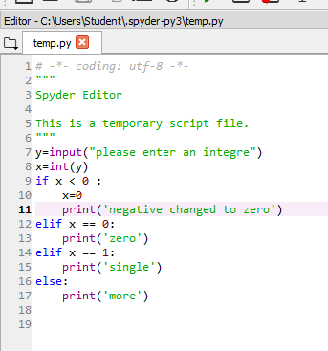

**Result/Output:**

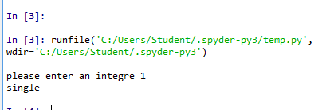

**Analysis/Conclusion:**

**We learn the concept of if statement.**

**Task # 2:**

**Procedure/Program:**

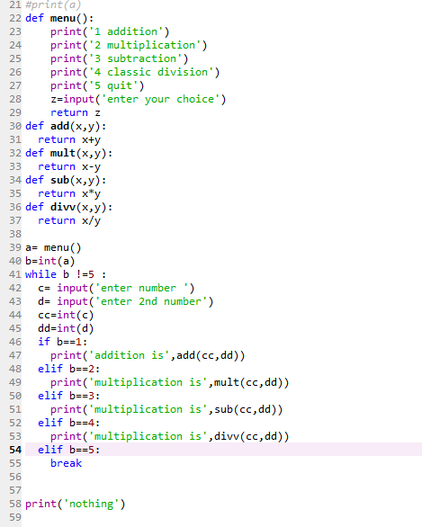

**Result/Output:**

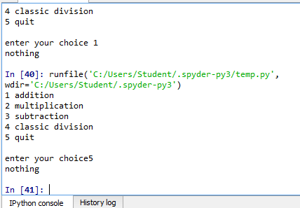

**Analysis/Conclusion:**

We learn how to call functions and implementation of loop.

**Task # 2:**

**Procedure/Program:**

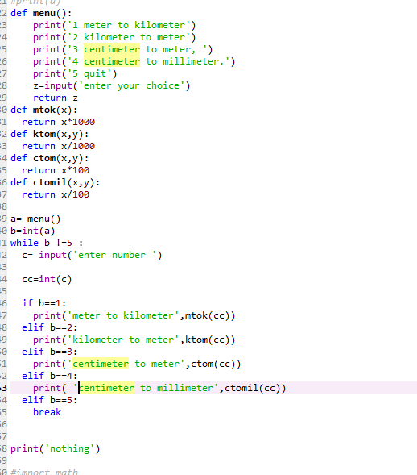

**Result/Output:**

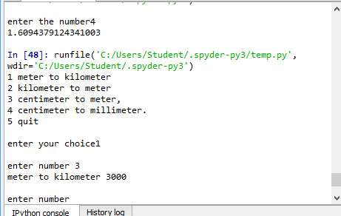

**Analysis/Conclusion:**

We learn how to call functions and implementation of loop.

**Bonus Task:**

**Procedure/Program:**

A:



B:

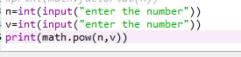

C:



D:

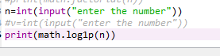

**Result/Output:**

A:

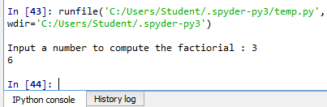

B:

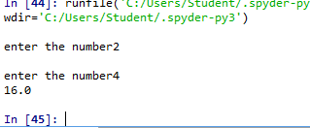

C:

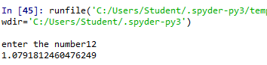

D:

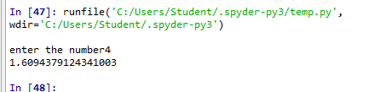

**Analysis/Conclusion:**

We learn about building function by importing module of maths.